Can you accurately predict insurance costs?

#importing data  
library(readr)  
insurancedata <- read_csv("C:/Users/Job/Downloads/insurance data (1)/insurance data/insurance_data.csv")

## Rows: 1338 Columns: 7  
## ── Column specification ────────────────────────────────────────────────────────  
## Delimiter: ","  
## chr (3): sex, smoker, region  
## dbl (4): age, bmi, children, charges  
##   
## ℹ Use `spec()` to retrieve the full column specification for this data.  
## ℹ Specify the column types or set `show_col_types = FALSE` to quiet this message.

head(insurancedata)

## # A tibble: 6 × 7  
## age sex bmi children smoker region charges  
## <dbl> <chr> <dbl> <dbl> <chr> <chr> <dbl>  
## 1 19 female 27.9 0 yes southwest 16885.  
## 2 18 male 33.8 1 no southeast 1726.  
## 3 28 male 33 3 no southeast 4449.  
## 4 33 male 22.7 0 no northwest 21984.  
## 5 32 male 28.9 0 no northwest 3867.  
## 6 31 female 25.7 0 no southeast 3757.

#we are checking number of rows and columns in our dataset.  
dim(insurancedata)

## [1] 1338 7

#checking the columns we have in our dataset  
names(insurancedata)

## [1] "age" "sex" "bmi" "children" "smoker" "region" "charges"

str(insurancedata)

## spc_tbl_ [1,338 × 7] (S3: spec_tbl_df/tbl_df/tbl/data.frame)  
## $ age : num [1:1338] 19 18 28 33 32 31 46 37 37 60 ...  
## $ sex : chr [1:1338] "female" "male" "male" "male" ...  
## $ bmi : num [1:1338] 27.9 33.8 33 22.7 28.9 ...  
## $ children: num [1:1338] 0 1 3 0 0 0 1 3 2 0 ...  
## $ smoker : chr [1:1338] "yes" "no" "no" "no" ...  
## $ region : chr [1:1338] "southwest" "southeast" "southeast" "northwest" ...  
## $ charges : num [1:1338] 16885 1726 4449 21984 3867 ...  
## - attr(*, "spec")=  
## .. cols(  
## .. age = col_double(),  
## .. sex = col_character(),  
## .. bmi = col_double(),  
## .. children = col_double(),  
## .. smoker = col_character(),  
## .. region = col_character(),  
## .. charges = col_double()  
## .. )  
## - attr(*, "problems")=<externalptr>

#we are checking missing values which is 0 in the case of our dataset  
sum(is.na(insurancedata))

## [1] 0

#mainly we drew the boxplot to check for the cases of outliers  
name<-insurancedata$age  
name1<-insurancedata$bmi  
boxplot(name,name1,names=c("age","bmi"),main="boxplot of age and bmi")

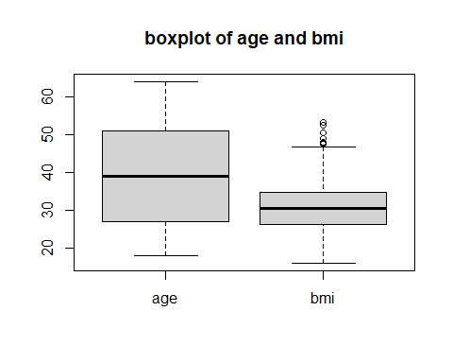

boxplot(insurancedata$charges)

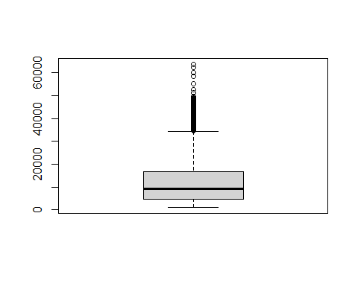

unique(insurancedata$region)

## [1] "southwest" "southeast" "northwest" "northeast"

summary(insurancedata)

## age sex bmi children   
## Min. :18.00 Length:1338 Min. :15.96 Min. :0.000   
## 1st Qu.:27.00 Class :character 1st Qu.:26.30 1st Qu.:0.000   
## Median :39.00 Mode :character Median :30.40 Median :1.000   
## Mean :39.21 Mean :30.66 Mean :1.095   
## 3rd Qu.:51.00 3rd Qu.:34.69 3rd Qu.:2.000   
## Max. :64.00 Max. :53.13 Max. :5.000   
## smoker region charges   
## Length:1338 Length:1338 Min. : 1122   
## Class :character Class :character 1st Qu.: 4740   
## Mode :character Mode :character Median : 9382   
## Mean :13270   
## 3rd Qu.:16640   
## Max. :63770

library(tidyverse)

## ── Attaching core tidyverse packages ──────────────────────── tidyverse 2.0.0 ──  
## ✔ dplyr 1.1.3 ✔ purrr 1.0.2  
## ✔ forcats 1.0.0 ✔ stringr 1.5.0  
## ✔ ggplot2 3.4.3 ✔ tibble 3.2.1  
## ✔ lubridate 1.9.2 ✔ tidyr 1.3.0  
## ── Conflicts ────────────────────────────────────────── tidyverse_conflicts() ──  
## ✖ dplyr::filter() masks stats::filter()  
## ✖ dplyr::lag() masks stats::lag()  
## ℹ Use the conflicted package (<http://conflicted.r-lib.org/>) to force all conflicts to become errors

library(dplyr)  
library(ggplot2)  
require(plyr)

## Loading required package: plyr

## Warning: package 'plyr' was built under R version 4.3.2

## ------------------------------------------------------------------------------  
## You have loaded plyr after dplyr - this is likely to cause problems.  
## If you need functions from both plyr and dplyr, please load plyr first, then dplyr:  
## library(plyr); library(dplyr)  
## ------------------------------------------------------------------------------  
##   
## Attaching package: 'plyr'  
##   
## The following objects are masked from 'package:dplyr':  
##   
## arrange, count, desc, failwith, id, mutate, rename, summarise,  
## summarize  
##   
## The following object is masked from 'package:purrr':  
##   
## compact

insurance1<-insurancedata %>% select(sex,smoker,region) %>% filter(sex %in% c("male","female")) %>% mutate(sex=recode(sex,male=1,female=0)) %>% mutate(smoker=recode(smoker,yes =1 ,no=0)) %>% mutate(region=recode(region,southwest=1,southeast=2 ,northwest=3 ,northeast=4))  
insurance1

## # A tibble: 1,338 × 3  
## sex smoker region  
## <dbl> <dbl> <dbl>  
## 1 0 1 1  
## 2 1 0 2  
## 3 1 0 2  
## 4 1 0 3  
## 5 1 0 3  
## 6 0 0 2  
## 7 0 0 2  
## 8 0 0 3  
## 9 1 0 4  
## 10 0 0 3  
## # ℹ 1,328 more rows

insurance<-cbind(insurancedata,insurance1)  
head(insurance)

## age sex bmi children smoker region charges sex smoker region  
## 1 19 female 27.900 0 yes southwest 16884.924 0 1 1  
## 2 18 male 33.770 1 no southeast 1725.552 1 0 2  
## 3 28 male 33.000 3 no southeast 4449.462 1 0 2  
## 4 33 male 22.705 0 no northwest 21984.471 1 0 3  
## 5 32 male 28.880 0 no northwest 3866.855 1 0 3  
## 6 31 female 25.740 0 no southeast 3756.622 0 0 2

head(insurance[,-c(2,5,6)])

## age bmi children charges sex smoker region  
## 1 19 27.900 0 16884.924 0 1 1  
## 2 18 33.770 1 1725.552 1 0 2  
## 3 28 33.000 3 4449.462 1 0 2  
## 4 33 22.705 0 21984.471 1 0 3  
## 5 32 28.880 0 3866.855 1 0 3  
## 6 31 25.740 0 3756.622 0 0 2

#k-fold cross-validation,  
library(caret)

## Warning: package 'caret' was built under R version 4.3.2

## Loading required package: lattice

##   
## Attaching package: 'caret'

## The following object is masked from 'package:purrr':  
##   
## lift

control <- trainControl(method = "cv", number = 5)  
model <- train(charges~age+sex+region+ bmi+children+smoker,data = insurance, method = "lm", trControl = control)  
model

## Linear Regression   
##   
## 1338 samples  
## 6 predictor  
##   
## No pre-processing  
## Resampling: Cross-Validated (5 fold)   
## Summary of sample sizes: 1070, 1070, 1070, 1071, 1071   
## Resampling results:  
##   
## RMSE Rsquared MAE   
## 6082.197 0.7488974 4204.662  
##   
## Tuning parameter 'intercept' was held constant at a value of TRUE

##RMSE (Root Mean Squared Error)the RMSE is 6082.311. This means that, on average, the model's predictions of the insurance cost are off by 6082.311. This value is relatively high, indicating that the model may not be accurately .  
##he R-squared value is 0.7473437. This means that approximately 74.7% of the variance in the insurance cost can be explained by the independent variables in the linear regression model. This value indicates that the model has a moderate fit to the data, but there may be other factors that influence the insurance cost that are not captured by the independent variables in the model   
##MAE is 4205.732. This means that, on average, the model's predictions of the insurance cost are off by 4205.732. This value is relatively high, indicating that the model may not be accurately capturing the relationship between the independent variables and the dependent variable.

summary(model)

##   
## Call:  
## lm(formula = .outcome ~ ., data = dat)  
##   
## Residuals:  
## Min 1Q Median 3Q Max   
## -11304.9 -2848.1 -982.1 1393.9 29992.8   
##   
## Coefficients:  
## Estimate Std. Error t value Pr(>|t|)   
## (Intercept) -11938.5 987.8 -12.086 < 2e-16 ***  
## age 256.9 11.9 21.587 < 2e-16 ***  
## sexmale -131.3 332.9 -0.394 0.693348   
## regionnorthwest -353.0 476.3 -0.741 0.458769   
## regionsoutheast -1035.0 478.7 -2.162 0.030782 *   
## regionsouthwest -960.0 477.9 -2.009 0.044765 *   
## bmi 339.2 28.6 11.860 < 2e-16 ***  
## children 475.5 137.8 3.451 0.000577 ***  
## smokeryes 23848.5 413.1 57.723 < 2e-16 ***  
## ---  
## Signif. codes: 0 '***' 0.001 '**' 0.01 '*' 0.05 '.' 0.1 ' ' 1  
##   
## Residual standard error: 6062 on 1329 degrees of freedom  
## Multiple R-squared: 0.7509, Adjusted R-squared: 0.7494   
## F-statistic: 500.8 on 8 and 1329 DF, p-value: < 2.2e-16

##Distribution of Charges by Region,we had the highest charges at southeast.  
library(ggplot2)  
library(ggplot2)  
insurance <- insurance[, !duplicated(names(insurance))]  
ggplot(insurance, aes(x = charges, fill = region)) +  
 geom_histogram(position = "dodge", bins = 30, color = "black") +  
 labs(title = "Distribution of Charges by Region", x = "Charges", y = "Frequency", fill = "Region") +  
 theme_minimal()

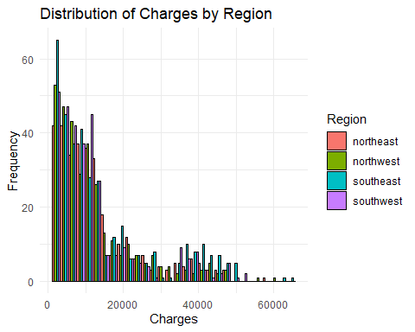

#Distribution of Charges by Age, we had the highest distribution of charges at 20 year.  
library(ggplot2)  
insurance <- insurance[, !duplicated(names(insurance))]  
ggplot(insurance, aes(x = age, fill = charges)) +  
 geom_histogram(position = "dodge", bins = 30, color = "yellow") +  
 labs(title = "Distribution of Charges by Age", x = "Age", y = "Frequency", fill = "Charges") +  
 theme_minimal()

## Warning: The following aesthetics were dropped during statistical transformation: fill  
## ℹ This can happen when ggplot fails to infer the correct grouping structure in  
## the data.  
## ℹ Did you forget to specify a `group` aesthetic or to convert a numerical  
## variable into a factor?

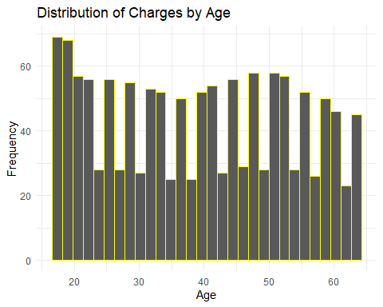

##those who did not smoke had the highest frequency of charges   
library(ggplot2)  
ggplot(insurance, aes(x = charges, fill = smoker)) +  
 geom_histogram(position = "dodge", bins = 31, color = "green") +  
 labs(title = "Distribution of Charges by smoker", x = "Charges", y = "Frequency", fill = "smoker") +  
 theme_minimal()

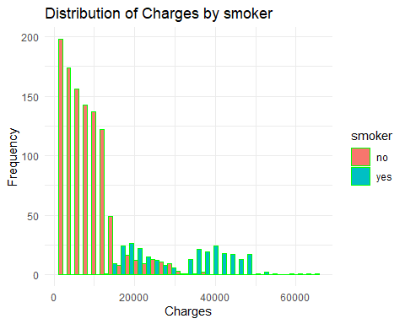

ggplot(insurance, aes(x =bmi , fill =charges)) +  
 geom_histogram(position = "dodge", bins = 35, color = "pink") +  
 labs(title = "Distribution of Charges by bmi", x = "bmi", y = "Frequency", fill = "age") +  
 theme_minimal()

## Warning: The following aesthetics were dropped during statistical transformation: fill  
## ℹ This can happen when ggplot fails to infer the correct grouping structure in  
## the data.  
## ℹ Did you forget to specify a `group` aesthetic or to convert a numerical  
## variable into a factor?

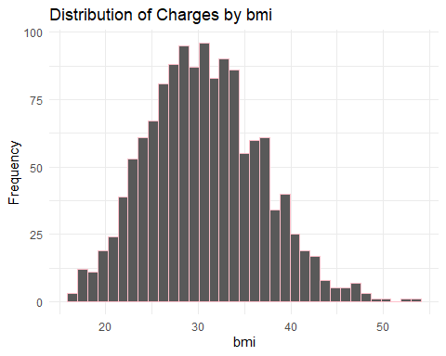

##male had the highest frequency of charges  
ggplot(insurance, aes(x = charges, fill = sex)) +  
 geom_histogram(position = "dodge", bins = 30, color = "green") +  
 labs(title = "Distribution of Charges by sex", x = "Charges", y = "Frequency", fill = "sex") +  
 theme_minimal()

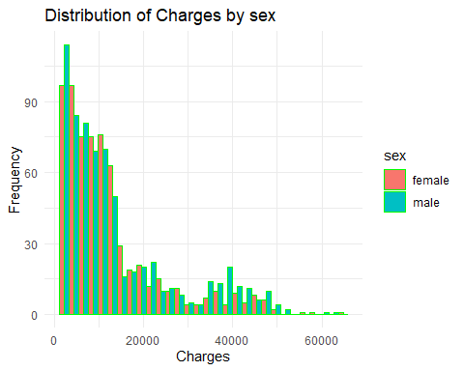

# Calculate the correlation coefficient between age and charges  
cor(insurance$age, insurance$charges)

## [1] 0.2990082

##correlation between different variables of the data.  
for (i in 1:ncol(insurance)) {  
 ggplot(insurance, aes(x = charges, y = i)) +  
 geom_point() +  
 labs(title = paste("Charges vs.", names(insurance)[i]), x = "Charges", y = names(insurance)[i])  
}  
plot(insurance )

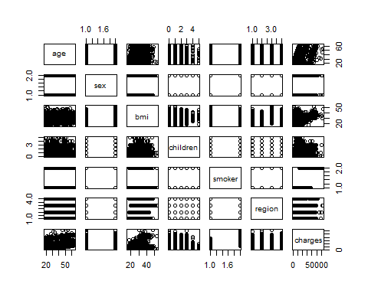

#age and charges are weakly correlated also all other variables are weakly correlated except children and charges which are strongly correlated indicating a strong relation.  
correlation_matrix <- cor(insurance[, c("age", "charges","bmi","children")])  
correlation_matrix

## age charges bmi children  
## age 1.0000000 0.29900819 0.1092719 0.04246900  
## charges 0.2990082 1.00000000 0.1983410 0.06799823  
## bmi 0.1092719 0.19834097 1.0000000 0.01275890  
## children 0.0424690 0.06799823 0.0127589 1.00000000